Risk Management Policy
- POLICY STATEMENT
The Board of Trustees (‘Board’) recognise and accept their responsibilities to ensure that risk management is approached proportionately to reflect the risks faced by the charity, and the size of the organisation
Major risks are those that would have a significant impact and a likelihood of occurring. If they arose, they could have a major impact on the almshouse charity in the following areas:
- Accommodation availability
- Governance
- Operations
- Finances
- Environmental or external factors such as public opinion
- Compliance with law or regulations

2 OBJECTIVES
The Board will take a ‘risk prioritisation’ approach in managing risk. The Board will assess risks on an ongoing basis and document and review a Risk Schedule in order to measure, mitigate and communicate potential risks to its key stakeholders.

3 RESPONSIBILITIES
3.1 Risk Identification
- All Trustees will report any significant risks to the Clerk or nominated risk management Trustee.
- The Board will undertake regular Quinquennial recorded Inspections of the almshouses and grounds and subsequent maintenance programmes should ensure that health and safety issues are given a high priority.
- All significant risks will be recorded in a Risk Schedule (D02)
3.2 Risk Prioritisation
- Trustees will use an agreed risk scoring model to prioritises the likelihood and impact of each risk. (See appendix)
3.3 Risk Mitigation / Action
- Trustees will identify and prioritise mitigating actions, and will work together as a Board to ensure that for high priority risks any such actions are implemented quickly and effectively.
3.3 Risk Assurance
- For any risks that are mitigated by a periodic action the Board will maintain a Governance Checklist (D003) of all such actions.
- The Governance Checklist will be monitored by the Board to ensure that all mitigating actions continue to be undertaken and thereby provide an ongoing and robust annual assurance.
- In the event of an actual significant event or disaster, the Board will review the scoring and effectiveness of the Risk Schedule, any mitigating actions and active Governance controls for their effectiveness.

4 CONSULTATION
- The Board will consult and consider potential risks from Trustees, the Warden, residents and external specialist.

5 DISASTER PLANNING
- In the event of a significant disaster (e.g., major flood, fire, significant vandalism etc) the Board will prepare and maintain a Disaster Contingency Plan, which it will review on a periodic basis.

6 POLICY REVIEW
- The effectiveness of this policy will be subject to annual review by the charity.

7 APPROVAL
This policy has been approved for issue by the Board of Trustees of Ravenstone Hospital Almshouse Charity
Date:..............................................................................................................................................

Appendix
Assessing and Scoring risks.
There are many different ways to score risks, the example below uses a scale of 1-5 for both likelihood and impact. An overall score is created by multiplying the likelihood and impact scores. These can then be colour coded to make it easier to read at a glance.
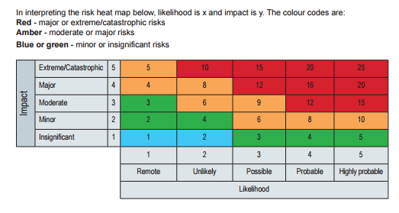
Table reproduced from risk management for charities: getting started supplementary guidance. Institute of Risk Management

